- University Management system
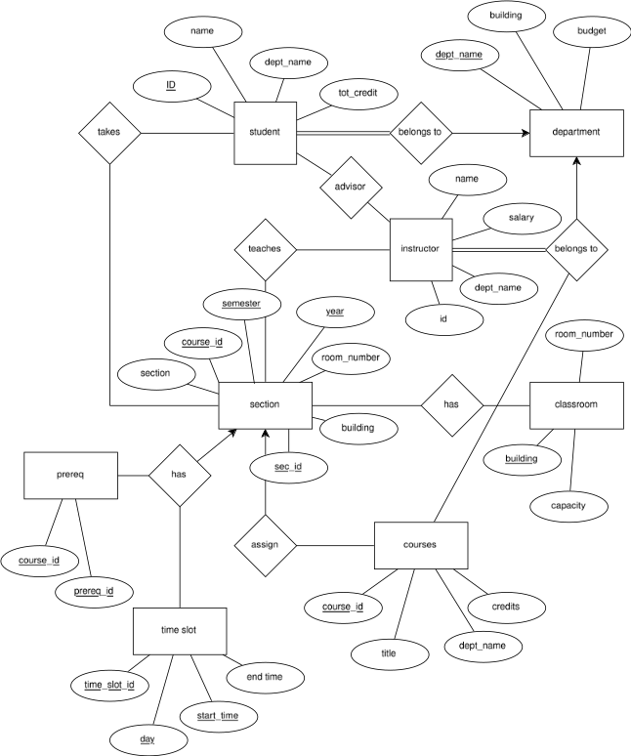
- ER Diagram of Hotel Management System

- ER Diagram of Library Management System

- ER Diagram of Online Shopping System

- ER Diagram of NoSQL Database

- ER Diagram of One-to-Many Relationship

- ER Diagram of Banking System

- ER Diagram of Hospital Management System

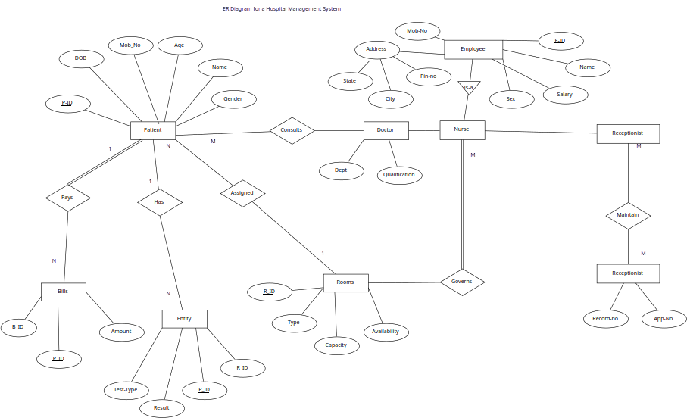
- Telephone directory Management system
